공개키 실습

과목명: 사이버전 개론
담당 교수님: 박대섭
과제 번호: 두 번째 실습
조: 1조
조원: 이성민, 이영준, 김민준, 박상희, 장서현, 오정현

1. 이성민
[이영준] 공개키로 암호화한 메시지
-----BEGIN PGP MESSAGE-----
hQEMA/SqUuTdnPY2AQgAqQMPbA6t3BtsR6vPZLgD1s4pdtdTznQ8LvWAeay4nizI
GR1o/K5iaHxlOvmGb6XgsKPeeSQ+ckMWS5ptAtXER+uM0UHddS34jw0wj2S/F1Vh
qsQx2ZJd2i8i7ZXK04aOTuKqqfqGlIN+hEmGb8yBM8Q5u7+ecebFnI6MFMnTaPcA
pVPJLvB7NsoWV/YKAqYn7Q5/Q/0H+V+sIz7tsbcNWF6Lab08ES956BbQJegxoKHY
4csDvAuOKQ2ki+8RTfib3oScAOEU6IfXSg+RePo27TQNPjXVntJHqMdiBxoglHJN
z0RmO55cKgE7DPaqlPlZpl/QFjH51nkkZ8NW5xFQ9NLA3AE8go1HRXnBLLee2sfx
CuS6zHBaG6DQybFASSCR9C0eGQPfIlHFK7kgs/ZbPoUqpAxkHhvdIPNT4ba3AQjz
w4vlrC2qttqUGAGuvS0/2up37k9gMGR0TbUt7j5S8STBipVcHrhRRqCPw1Lwaa57
EcPKYxuHK6bKiOwSQZ14ff4TXBdWl6mHmeLdEgYd2e20K7zFKQwikkQ7bIqDVX2W
/OgPYDPwFxMHQAFCGRAneT6piOT8fdRMJD0UyY1/NY1TGrC1s9sz9HjhBpVjmSJ7
ZugU9LPjKEvO/9WRo4kOY9f7QdG/h24gjx0FqZq6MgUVRKkaLjtj+GnA4VPtamqX
PHGy7WPoyKkt28VhNJC39vH5KuoMqVjDUnWC1EUz8tthYuRfMJnc9rPNcxgPuib5
ZfRL7gEO35ki9SZr7cTBEozoCCgFg2k1C1wX0KuGvh8X/rZMEwi2gO8C/ys2vHYW
JeyCO6QY8b8PDZ1HGjVfydRxdn+5tlg2ZCv4/kIU9DEGKYLUQReCbS724xZN53pM
bHW/Fsoam/J7jzy7ahg=
=tnpr
-----END PGP MESSAGE-----

2. 이영준
1) [이영준]의 개인키로 복호화한 메시지

Great AMD CEO Dr. Lisa Su

2) 추가적인 내용 기입
Great AMD CEO Dr. Lisa Su from

3) [김민준]의 공개키로 암호화 및 전자서명 추가

<결과>
-----BEGIN PGP MESSAGE-----

hQIMAyCuwb1Gy8KZARAAqbOwcoiRmAIXFL6WD/ZuJ8qibXgB0OgOZ5gDlYhCb8c3
lL8miG2hCqG9SJbytvL9XHyej2Nt2FODnkPp46yYnEjL8U5IxnNApeC3wtfdpsCu
RlIxvo6G8sk4czwl/E6ScctFSw+kfSPF/KT2VBBx1pJtIhlDAOLA6EFg17OVuZwh
GzkQYaN//2Z7N+L8676Mh0Qs6JsBsQr0AT3OCQvW1cgvq9TIlpRKko2Ia4ABIA0s
O3lHhAdb0a3i1xNpg0U3isCqxnY95wsNbH1WRIP35xYH0FBKxXxyYfYj8pekg1Be
2rB9KoDGcfUfwVIYVL+aiZYkW5G65BWIfPGNhp4YbDa704o0Dtww0D47uG5xl15X
yb6Ph9zwvcflEK5li9axE/yye4UW6u+oz8cnY+8MNSq4na86mHt8sHWp5Y3toiRP
aFd0Uc7COAFToPcZADhR6PC1dZ9+yMvA6YpDWL7yl7AEkZCM6QRQnLjfwLM0gLEJ
vvuSXUPNbfuD9ljWOKRBl4ngvh3tOJRWy98UP4H9rioTQzYk7ocsBn8SYeO7koSV
uGvT6/UZn8txEP6mqf6tPHurD99HSXUAqGguoUDvk0EuTBFiWd1lGSYXJneZGQf0
qQrjpKKzkHjfALQIYZ14/FnSsCYPbZ1+f39ibxprF5iR+TjlznDe0YKqUyiNCv7S
wOEBZoqhPxUHBvrvvoeZ5//AM+WX9UqTGquMehmwZj5Ac3CgYPLpaUojE9faDr+T
AVMEVjpTmtu0h/8kENPgbY4E0FgyVIeKX6LeDTSjSlwcJsw+fCfsyhlKOcPkbASM
XV9xu6ALGQ6n/vAEbEUPc+2wi3w5yN6l5rvcOZ+IxNb8g4TbJlxEq3hN92SIMzXK
GPaAiFOGKr2OVXG7cSGkypNIpUZJz0dJ18O3FX/5uHRqdaYL6G4fzVlE/cLz4zkh
C9xh4t8pkcnz7/XMvWOpTIRDntoXNkCrRBSwPNc6pAQtHTVYR0BZmpv0tVFdRtMc
05clvnohfuYaeJ2yGv/2Fuh9BcIZqViFbJbdUD7JGGoSCX7gqhVM0JqO6zKSKOVQ
Lo3P12ufB5r/xJTxidYtRrWW3D3gdm2IRnj6qhMOkyURnbw8rEHt/Z4IvQdklX9s
XpCBxVvHEeLjMCNtEogOj+yyMX2vW0c3cPhXWgero7noswWrLB1/qzqnASQu4Dzf
JzuMk1WzgJRyM2onWE6X4bmmsAoel6J2X0ho85QD31vNP2g=
=OjcC
-----END PGP MESSAGE-----

3. 김민준
1) 개인키로 복호화한 메시지
Great AMD CEO Dr. Lisa Su from

2) 내용 추가
Great AMD CEO Dr. Lisa Su from pwn import*

3) 박상희님 공개키로 암호화
-----BEGIN PGP MESSAGE-----

hQEMAy/bHnuoZMOVAQgAjzmwC0yJJ+S/lKqpqhKCWUydWxB9GOiHVtnisgvWqQvx
r6XrOXvL/k3ZHKr4newnhLUC/zOsHgTV+f500WhDiQT9CFOTVBnFJfIK1lw5dPWr
P+h7OXPwuq0JWNl6NpHQ0CiZQg2OgPytizT4evTE0yjx318kzFEnHRdEsjMiVHay
vonl2Mw/DPxd3L20vY9Ft1kw7TWoRgSsZARAEqZmZHp9MzjsxCjWbxFevhcNv6cl
rotn431mP5gdSWA3Fm+R916uHYkNYUod0VAZfcjLc4stTdHF2LFVwVlF7VS/iR9v
TXkermARObh8GkDd1sAhU2+fdUaL3P1bKeKyTudkltJsAanAHwnTLWQKU352CfPU
bi61MmB9steOi+ZwJT9brUtEeRUMTiog3OBJd1zPl57BDbrFGTs5Nu+8+0PEUZAg
RHOkHQcW2cgESJ6nKcn6yt7DsLWdDZRx6MJrgrgm5rKtCjqIWEHmYrFIWDRV
=tdWf
-----END PGP MESSAGE-----

4. 박상희
1)[박상희]개인키로 복호화한 메시지
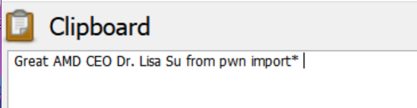
2)메시지 추가
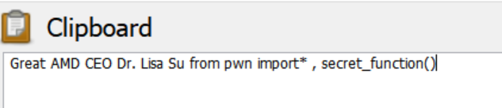
3)[박상희]비밀키로 전자 서명 및 [장서현]공개키로 암호화
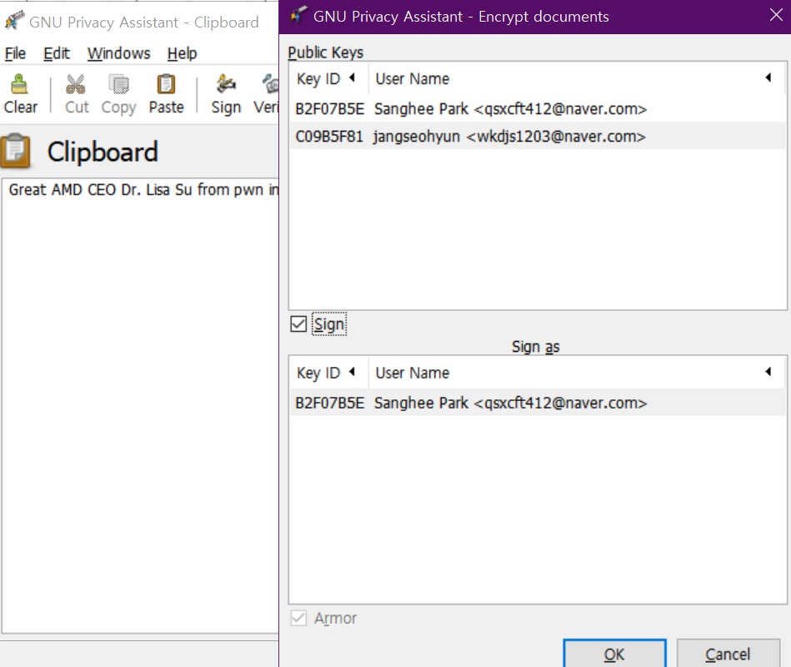
4)결과
-----BEGIN PGP MESSAGE-----
Version: GnuPG v2
hQGMA7jHp7VT1OWBAQv+MFlsibFQm3PpuS2L507mMYQmMGGxpvF1TdKsvx6l1hja
50rtqbfQmCpX00jUO2pAfk5FG5dbnIlZGgH9b6R1a+ITyno8FaJd1QAmEaVas2de
2BtKGzxC1C/fPYvZ0pdAFzJV7LQ+Ss+X3ZbVkW0vVhdY2BIQiV9EuBcD0hrGLI8b
wdruJWP/yFiAPWwX+3L/3w3NxD25QyPzyrschhOmf/kapmIDCbINStzNE/GCksgJ
SLgO+xERm2j7jDxghulENZv/p/Dd0iHSk7aBRE/FxKtnkFPHGQAMfJohCPoE5InS
leTopBwvYnHZY5a6he1Yj5zFUVezHtSnxHlMJcINc98R9vYjDWL5XsqxEC1GZD0S
D2fUJj1eUhAp5xmLKXgaeEvykjs9o4ntPxJrNYQKRZzpVRZ05ZOKmIo3qsQ3j2hE
RvS3Sr1wb+fHCtNdr3asifT2hQpJOGvoNd11xhcrL0NXXprks1gFVhqdIBgywYFE
Yjj2+1ZpyM2r7elg3cPc0sDqAXN5cKNxQ2dljTRqChXPlZQ0kK+UL5OoBSP36FZ+
wik8vmTrgtLSpApd3ZSfqiIRWqh6iHmCN7Ee9P3sOrKGCRhmhab3tCZJgD2bxJXk
8Nf3BPwqH9m55vCrwmM7UnmYEnGk89R9Wg4wsNstfdtbm/czAMwyoeZUkiC7U9c7
ysfhEn5zBS28EcPbdeLQMLRVNzXpW7gpcdJAp7ke5Gg5dUgUPsvXOYpni7VujeYy
6IkmKDFs6dwN4V9Gc9WqwIgaO3jePNew4elu2T6FhpEKg1KFrFLJ10Sm6P3B2j7l
GASqaV6NOEo4ysLNb0TIV0okIE56rhASJrC6NeieP1WprwVGIC/NRbcQry+NKtl4
oalQN+F+up4MEHUA9BGhEtnTvP/D8P8mh1nJCH/vBhoZHYALJd1EsOw5vMJ0YjOE
UH4cBZqnAVMaUHw/h2jrCqdt3QbAn/LYM+j3EjRAQ1CXhcrI/R2W0Pfl7zN1PZHj
/7oBTZail4hahnWSe0jmXYCuGGo1B8Hqxg34mrS1ZuZdHO3yiLuH3GUdxXEXgy4a
kbskeaxrXTltFiDl
=YKTe
-----END PGP MESSAGE-----

5. 장서현
(1) 개인키로 복호화한 메시지
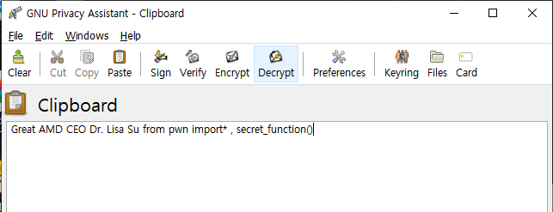
(2) 메시지 추가
Great AMD CEO Dr. Lisa Su from pwn import*, secret_function() cyber

(3) [오정현]의 공개키로 암호화
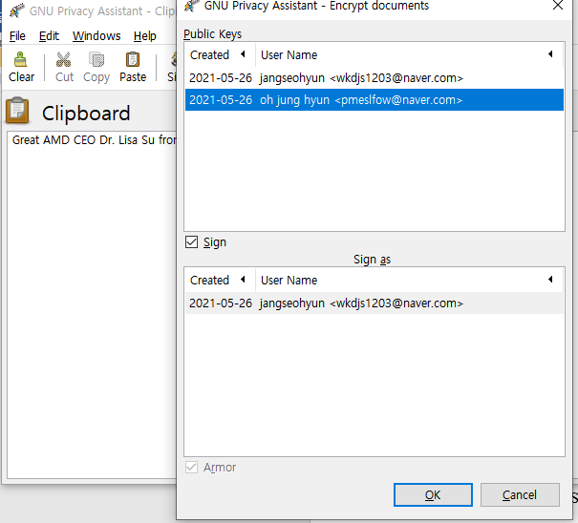

(4) 암호화 결과
-----BEGIN PGP MESSAGE-----

hQEMA0lfnFhTJwveAQf+NhQFIrpLZKtELb5gp07anajUgQ17gQW3cnnjUiE31QVK
PgaSTzBnL7+IHaZs0c5knyqYAf2COrrJ7d7x6/eYvQ+2YDZcsrY+wbfXS1//IJDi
UuKBX0+xXBMg5IsdkrymLG7aMr5mqgDcVJfCCKmxJ4kX4ITt3TZSsY2dsYHKUDPf
05hI13o/bRH/1NR/IZFlJjmzhHbUqJQfxdFTbnPxeV2LOWVjPZVCgT9a4Iam3jru
DRqH08PkuWdZuDSYulplbmvbYwQnbo0wdrrh71lVSXyvRCJXgbBADo1i+gdScVi+
u6eSCJDLvzRW/FwXUkRfFwU1rBQc0g9311y9p1koqtLpAc8xfRttbm5I8QApNzL1
Gs4LvvxbxOdJiuPkHTchbgxiv2xWERujYN2yf8GNQ+R90tP677A35678LFKmntRj
jD5Un3ccCyXw7B+XcYHPnOr7qfhlw8kzE0yvgaSuQeDJwZhAgF4sCxVW+99d32JT
nqUjv7LZr8W9tmi4P/MucTeXP/HHul9qwcElZDA3WK6QIzMwDohiF6LfNT6Shr39
VL+btRsrpTSnhQbwm/6MDDbAIip3eBaFqAwGAVaBIIQgc+pgiIdNcb7hgvNhOHkt
ln+8Vw6B4BiSs3M/SZL5ZNaJS21loTYKuk84vgxOC2UI/b/SDB88e6tTiPZhSxkd
RSvPfHtMeQ0xetdFvOA8lLdw45/V2MZXJTxYiNWsgLCOgDIE4NLrjpE+GKM+/DBu
6rpf953A1hd2PHOUGQW5ibMVUXhSpeaTTdFsqaabBCbgv+PvmojeCAvewOQ8OKZg
3U+tiSjLmH88bCoNN8aaTeGcc+eNk+TLtAWx99yqnI+YXhd2UDxTsVJ2xgps89cX
DAg29lyj7J0FKysO0aIsuKjCCCNvxc5j6hJ9FLLq6ireUQb8mfD/051VlP1dAalz
DsYlo2quCzf7c05KZWA5AhNHaS8SlsgPOb4ibreZ1GjKKYZpDecZaDEuAV4MZBwN
Us72HArQlXAYurcoWzMWBopHpGLwNcu5lpdpQ6NEsV8V8ZgxvlyOAb8JNPx3OMqh
wv6oyqXEMBRGsAgqpwFP+1oPF+Mt8nX3GkYHvRFl/f7RTW19JOaooIk=
=OdkF
-----END PGP MESSAGE-----

6. 오정현
(1) 개인키로 복호화 한 메시지
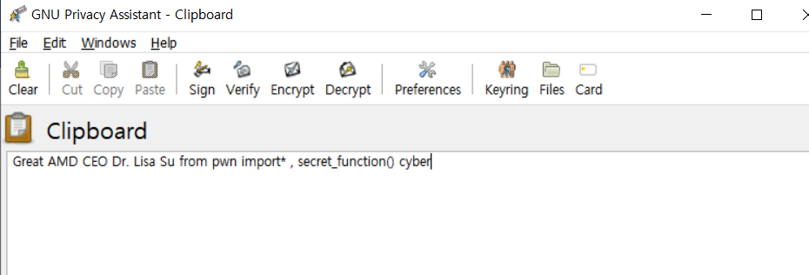

(2) 임의대로 메시지 추가
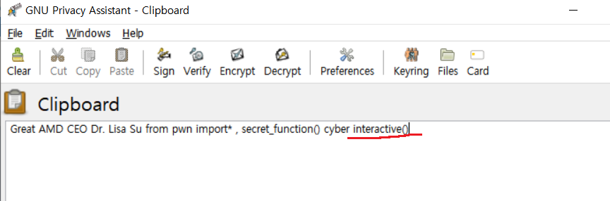

Great AMD CEO Dr. Lisa Su from pwn import*, secret_function() cyber + interactive()

(3) [이성민]님의 공개키로 암호화
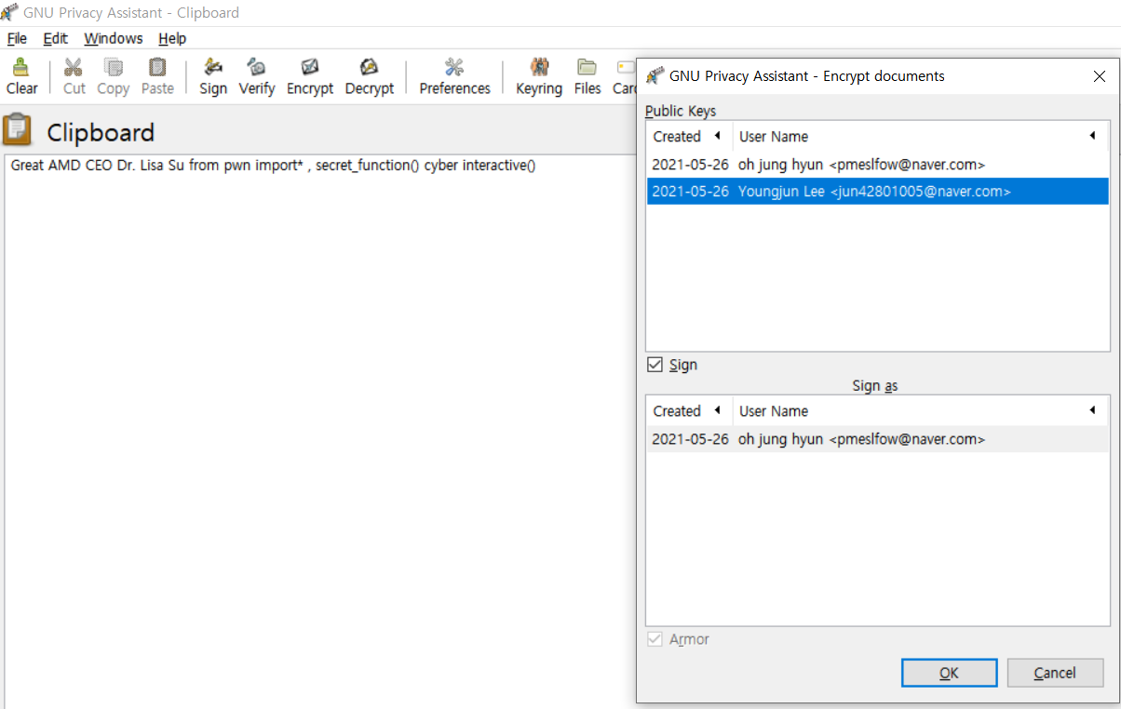

(4) 암호화 결과

-----BEGIN PGP MESSAGE-----

hQEMA/SqUuTdnPY2AQgAmSlhQwAJD0JhltZWpF8bG0GnEpz4yfjOyIlaSpk6GXYD
pi6VcUvDFUbVPRu+yj+6rd4zo+6imi/hcqvN0XzGT+HvmhI0UyZFa//xEZ1wMMT+
9HSyPgZ9DX1zBvk6hLHXti4IgXTGLyPSExbDS5WmfQkOQIa0CCqyD2m4U9oB6tRg
IWZpQozIU91UKK0mWWsMLrMSxMQdnCdvBs2eGDfQanlz7oDGq6cLygcenaHOKjvB
krOA25J5GQ+93lDUEIdjwo25M1qWYCvFpJuF2Ic4v++1VGqgTruRms4MXzpilVXq
5AKJQNkc1jhE2KjivIlUWPyYWmdIhEC5wBjCD7p6MtLBEgHuVD7y3X90bh1WNDdN
8pXh2FKS/5pFQRP8RtnroSanH0gzT/EwthnJcYBmFIUW+A/JMboTa3TKYLJh2vER
BetGurjSYMaxibJlPRz/Re2na/LVrSH1U8tgWni+EOqFFNX1kwInjy8g2kvV1caL
BgxjED9KQXQUznxddtg/nfwlX4uFSk6333EcS2HggPJg2tguUctsoHvgkwHdrIBC
/qogDXb/L/pEBo7ezuA5Kb77j55bzWk2CqDaw1PEEBMkNHWb7rf5hJ4Dra6R97tv
mxe0DxLZMjfqg7yng2DBXuNmpVGIwzO7D/mUkNIwt9rLTX3zTAPvNDXjMI0E0OZv
LoewvOuFgL8ha8jKX261knJ7hqcTLTp3yIKhiiNVfbUN0JyOSQ2IOcLHb4gYHr/W
BvcOMyJ7JYdr1Dy37aFOhhYiL+ZKS/c35TOU3KwJq+UoDGuoWIbIGmF0GhGApd8p
9oSnSPq5VeDck0JdYk5ELobF/e8cwNUhU6uNcK3f5CgvB39w9v4LNyZTAtjz4Pcc
ANaijEw4WUL2970xos/DQFMhA773KohFu60DtBbAdueScgKVOVqV3cFd/BEviEQi
rP/T0ek9689dqcEkThx3DTzRn+A=
=nedy
-----END PGP MESSAGE-----

최종 복호문
